# SQL Script

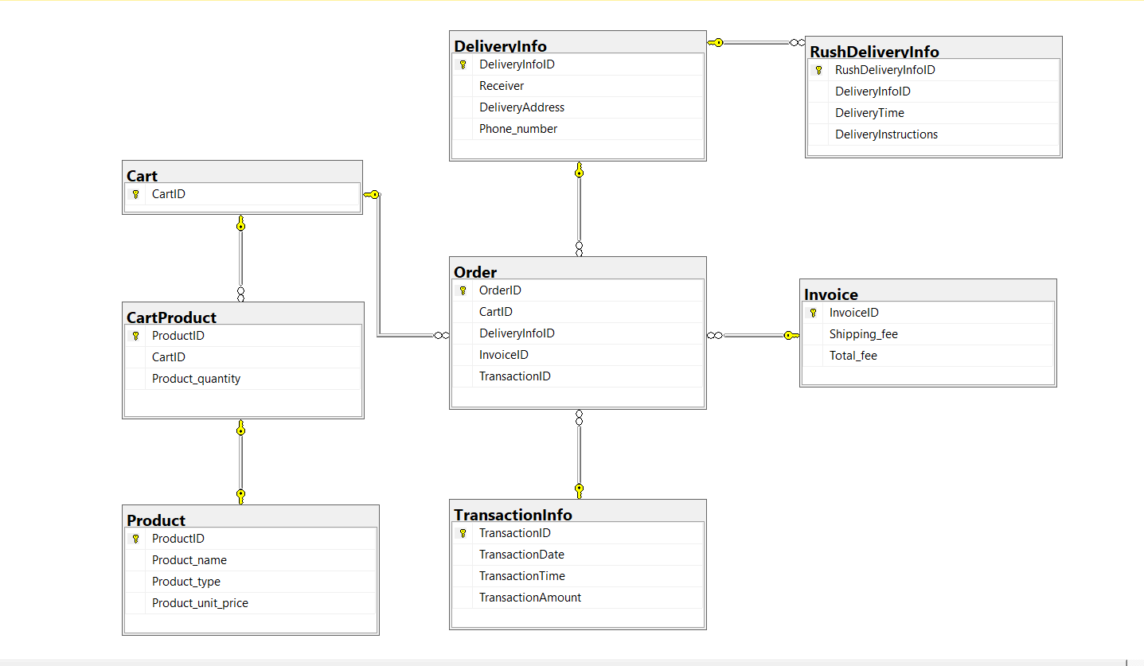

CREATE TABLE [Product] (

ProductID char,

Product_name varchar,

Product_type varchar,

Product_unit_price float,

CONSTRAINT PK_Product PRIMARY KEY (ProductID),

);

CREATE TABLE [Cart] (

CartID char,

CONSTRAINT PK_Cart PRIMARY KEY (CartID),

);

CREATE TABLE [CartProduct] (

ProductID char,

CartID char,

Product_quantity int,

CONSTRAINT PK_CartProduct PRIMARY KEY (ProductID),

CONSTRAINT FK1_CartProduct FOREIGN KEY (ProductID) REFERENCES Product(ProductID),

CONSTRAINT FK2_CartProduct FOREIGN KEY (CartID) REFERENCES Cart(CartID),

);

CREATE TABLE [DeliveryInfo] (

DeliveryInfoID char,

Receiver varchar,

DeliveryAddress varchar,

Phone_number char,

CONSTRAINT PK_DeliveryInfo PRIMARY KEY (DeliveryInfoID),

);

CREATE TABLE [RushDeliveryInfo] (

RushDeliveryInfoID char,

DeliveryInfoID char,

DeliveryTime time,

DeliveryInstructions varchar,

CONSTRAINT PK_RushDeliveryInfo PRIMARY KEY (RushDeliveryInfoID),

CONSTRAINT FK_RushDeliveryInfo FOREIGN KEY (DeliveryInfoID) REFERENCES DeliveryInfo(DeliveryInfoID),

);

CREATE TABLE [Invoice] (

InvoiceID char,

Shipping_fee float,

Total_fee float,

CONSTRAINT PK_Invoice PRIMARY KEY (InvoiceID),

);

CREATE TABLE [TransactionInfo] (

TransactionID char,

TransactionDate date,

TransactionTime time,

TransactionAmount int,

CONSTRAINT PK_TransactionInfo PRIMARY KEY (TransactionID),

);

CREATE TABLE [Order] (

OrderID char,

CartID char,

DeliveryInfoID char,

InvoiceID char,

TransactionID char,

CONSTRAINT PK_Order PRIMARY KEY (OrderID),

CONSTRAINT FK1_Order FOREIGN KEY (CartID) REFERENCES Cart(CartID),

CONSTRAINT FK2_Order FOREIGN KEY (DeliveryInfoID) REFERENCES DeliveryInfo(DeliveryInfoID),

CONSTRAINT FK3_Order FOREIGN KEY (InvoiceID) REFERENCES Invoice(InvoiceID),

CONSTRAINT FK4_Order FOREIGN KEY (TransactionID) REFERENCES TransactionInfo(TransactionID),

);